SURA 2015 PROJECT PROPOSAL

SMART CASING

FOR

SMART PHONES

**Student Information:**

**Varan Gupta Rishabh Baid  
2013ME10737 2013ME10712   
Mechanical Engineering Mechanical Engineering   
+91-9013315332 +91-9650410727  
CGPA: 8.833 CGPA: 8.852**

**Facilitator:**

**Dr. Sudipto Mukherjee**

**Professor**

**Department of Mechanical Engineering**

**Indian Institute of Technology Delhi**

**Hauz Khas, New Delhi 110016, India**

**Phone: +91-11-26591138 (O)**

**E-mail: sudipto@mech.iitd.ac.in**

**Signature:**

**Head of Department:**

**Prof. S.R. Kale  
Department of Mechanical Engineering  
IIT Delhi**

**Signature:**

# Objective

To protect mobile phones from accidental crash using protective casing. It will be

* Capable of protecting phone from major damage for drops up to 4ft.
* Cost-effective, aesthetically pleasing and light weight.
* Capable of being developed into mass production product.

# Motivation and Related work

In our everyday life very often we happen to accidentally drop our mobile phones and to add to our misery most of the times phone fall with the screen facing the ground. With the screen being the most valuable component its repair expense almost matches the current market value of the phone.

Recently, Apple secured a patent [1] , which focussed on reorienting the I-phone by altering its angular momentum in mid-flight via rotating or linearly sliding masses so as to save sensitive components from impact. It also consisted of solutions like using motors for extending and retracting aerodynamic surfaces for controlled landings, using miniaturized gas canisters that exert thrust forces to slow down a fall.

# Novelty

Taking inspiration from our own experiences and the patent mentioned before, we wish to develop a generic mobile phone casing. The casing is to incorporate protection mechanism which is new to **Indian market**.

# Approach to the proposed R&D project

We will be focusing on mainly four tasks:

## Idea screening

Initially we will be exploring existing solutions, and then keeping in mind their pros and cons will come up with new ideas. Based on the viability of ideas we will select the best one.

## Concept development

There are mainly two areas where we need to focus namely:

* **Detection**: We need to detect whether the phone is in freefall or not. To accomplish this we plan to use the sensors already present on the device like accelerometer [2] and gyroscope [3]. The inputs of these sensors will be processed and then sent to the microcontroller on the case via NFC [4] or USB [5] for the activation of protection mechanism.
* **Protection Mechanism**: The most fragile part of a mobile phone is it’s screen. Nowadays, most of the mobile phones comes with “Gorilla glass 3 [6]” with thickness .7mm, which can withstand up to 100kgf [6].

If a mobile phone is dropped from a height of 4ft.

$$v=\sqrt[2]{2gh}$$

$$h=1.2m (i.e. 4ft), v=4.85ms^{-1}$$

Taking mass of phone, *m =* 160g

Kinetic energy, KE = 1.88J

As mentioned before Impact Force < 980N. Assuming that all the KE is dissipated in the impact,

$$\frac{KE}{d}<980N$$

Where, d is distance travelled after impact,

$$d>1.92mm$$

As the thickness of screen is itself .7mm and surface holding is it not so flexible, the screen will shatter [7]. So, we need to synthesize a mechanism which will ensure d to be greater than 1.92mm.

To accomplish this, instead of re-orienting the phone, we thought of using supports that will come out of the casing with the help of interlaced wave

Springs [8] . The supports will be placed such that the phone falling with different orientations will be saved from impact.

Further, the supports can be locked in initial position using miniature electromagnets or a Nano Planetary DC gear motor [9].

## Proof of concept

Before proceeding to the manufacturing phase we would be going through the proof of concept phase which would involve testing the circuit on the breadboard before printing the PCB and building individual mechanisms to establish viability and feasibility of the finalized concepts.

## Designing and Manufacturing

Next we will be concentrating on the final layout of the cover such that it accommodates the designed protection mechanism as well as being aesthetically pleasing. After this we will begin the manufacturing of our first prototype.

## Testing and Improvements

After completing manufacturing we will start thorough testing of the prototype.

For further assistance in the improvement of design we will incorporate machine learning [10] which will reduce false triggering thereby increasing the reliability of the system.

The various data from sensors can be sent to mobile phone manufacturers so that they can relocate the most vulnerable components or change the shape of the device to better withstand most common freefall impacts.

# Duration, Facilities and Budget required

The tentative working schedule:

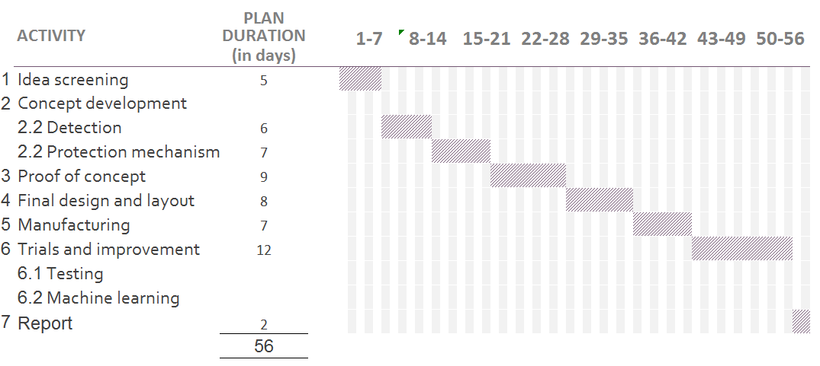

We will be requiring 3D printing and circuit designing facilities like PCB printing, soldering etc.

Although our eventual case would use already present sensors and processor in mobile phone for functioning but for testing purposes we will require to purchase them.

The budget would be split up as follows:

| S. No. | component | Estimated cost (INR) |
| --- | --- | --- |
| 1. | Accelerometer and Gyroscope module | 475 |
| 2. | Beaglebone (microprocessor) | 4000 |
| 3. | Interlaced wave springs [8] | 400 |
| 4. | Pre-owned android phone | 3000 |
| 5. | Micro motors | 800 |
| 6. | Microcontroller | 175 |
| 7. | Miscellaneous | 2000 |
|  | Total | 10850 |

# References

|  |  |
| --- | --- |
| [1] | Apple.USA Patent US20130257582, 2014. |
| [2] | MEMS_Accelerometers. [Online].  Available: http://mafija.fmf.uni-lj.si/seminar/files/2007_2008/MEMS_accelerometers-koncna.pdf. |
| [3] | "Invensense," [Online].  Available: http://invensense.com/mems/gyro/documents/whitepapers/MEMSGyroComp.pdf. |
| [4] | B. Dodson, "Stanford University," [Online]. Available: http://mobisocial.stanford.edu/papers/nfc.pdf. |
| [5] | "Android phones with microcontroller via usb," [Online].  Available: https://www.youtube.com/watch?v=WzfVezAcNJk. |
| [6] | "Corning gorilla glass," [Online].  Available:http://www.corninggorillaglass.com/uploads/kcfinder/files/Gorilla%20Glass%203_2320_PI%20Sheet  %20RevE_050613%281%29%281%29.pdf. |
| [7] | "Nexus 5 drop test," Android authority, [Online].  Available: http://www.androidauthority.com/nexus-5-drop-test-314862/. |
| [8] | S. s. r. co..USA Patent US5639074. |
| [9] | "precision microdrives," [Online]. Available: www.precisionmicrodrives.com/dc-geared-motors/dc-gear-motor-ranges/nano-planetary-range. |
| [10] | P. Domingos, "Department of Computer Science and Engineering , University of Washington," [Online]. Available: http://homes.cs.washington.edu/~pedrod/papers/cacm12.pdf. |
| [11] | "Lee Springs," [Online]. Available: http://www.leespring.com. |